Social skills are very important. We encourage good manners at all times, más é do thoil é agus go raibh maith agat, addressing teachers properly, being courteous to fellow students and teachers. It is important to ask your child whom he/she played with at school and to ensure he/she isn’t alone, also encourage mixing rather than being dependent on one friend. Rough behaviour is totally discouraged in the playground. You will be given a list of our school rules .

PARTING THOUGHTS
Who is the Boss?
Bit by bit the child will get used to the general discipline of the classroom. He/she will get to understand quickly that in certain important matters an instruction from the teacher must be obeyed promptly.

Teacher and Parent
At the early stages some parents meet the teacher almost daily and this is a very desirable thing. However, if there is something in particular that you would like to discuss you can arrange to meet her at a time when you both can have a little peace and quiet. Please ring the secretary / Class teacher at 097-82283 to make an appointment
.

Easy Does It
There are lots of ideas and suggestions in this little book as to how you can help your child. We are not advocating that you do ALL of these with her/him in a systematic way. But if you find from time to time that she/he enjoys a fun approach to certain aspects of learning then we would say - give it a go - but remember don’t overdo it.

Our Hope
We are offering this Guide to Parents as a little practical help in dealing with the education of their children at the very early stages. We will be very happy if you dip into it from time to time and find something in it of value to you and your child.

Go raibh maith agat / agaibh.

______________________
Catherine Mc Intyre
Príomhoide.

Scoil Mhuire
Gleann a’ Chaisil
Bun Na hAbhna
Co. Mhuigh Eo.
097-82283
Ríomhphoist: gleannachaisil@gmail.com
Suíomh idirlíon: www.gleannachaisilns.ie

Seo leabhrán beag a bheadh cabhrach do thuismitheoirí a bhfuil paistí leo ag freastal ar ár scoil I mbliana

Fáilte go Scoil Mhuire Gleann a’ Chaisil

Some General Information for Parents of New Infants starting in Glencastle N.S.

Tá fáilte romhat féin agus do pháiste chuig Scoil Mhuire Gleann a’ Chaisil.

Starting school will be the first big change in the life of your child. Up to this he/she has felt safe and secure with you in the home and family but now is facing the wider world of classroom and school. This may seem a big step for someone so small but most children manage it without any great fuss or stress - and in fact take to it like ducks to water.

However, it is also a time when parents and teachers should take special care to ensure that the transition from home to school is as smooth as possible. If the child’s first experience of school is one of happy involvement, a very good foundation will have been laid for fruitful school years ahead.

It is important too, particularly during the first year, that parents understand what the aims of the school are, as many may be expecting too much in the way of academic achievement.

We know from experience that parents are very anxious to help in any way possible. We have, therefore, included some ideas for the home, which should stimulate the child’s interest and nurture a desire to know more.

With these aims in mind we have put together this little booklet as a general guide for parents. It deals briefly with the period before your child comes to school and the introductory stage in Junior Infants.

We trust you will find it helpful and that your child will be happy and fulfilled

You Can Help ...
- He/she must develop the ability to get the hand and eye working together. This is very important. Get them manipulating toys like:
(a) Jigsaws, Lego, beads to thread etc.
(b) Plasticene (Marla) to make their own shapes
(c) A colouring book and thick crayons
(d) Sheets of paper that they can cut up with a safe scissors.
- When he/she begins to use a pencil make sure that he/she holds it correctly at the start. It will be difficult to change him/her later.
- He/she may be making block letters at home even before he/she comes to school. This is fine. But when he/she starts making lower case letters at
school you should try to get him/her to discontinue the blocks and practise his/her new system whenever he/she feels like it. Consult the teacher about this.
- Don’t discourage left-handedness. If that is his/her definite natural inclination, don’t attempt to change it
Other Areas of the Curriculum
Children in junior infants learn a lot through many other activities, which do not need any elaboration here. Their general developments is enhanced through Art & Craft, P.E., Music, Nature and through Religious Education.
Children’s moral and social education is covered right through the school day e.g. kindness to others, sharing with them, saying we are sorry, being aware of God through the beauty of nature etc. Each year the children along with their class teacher compose their own classroom and yard rules. The rules tend to follow the following format..

Do’s Don’ts
Do be kind and helpful Don’t hurt people’s feelings
Do be gentle Don’t hurt anyone
Do Listen Don’t interrupt
Do work hard Don’t waste your or other
people’s time
Do be honest Don’t cover up the truth
Do look after property Don’t waste or damage things

But You Can Help ...

- In the course of your ordinary daily routine in the home, in the shop, in the neighbourhood you should use suitable opportunities to casually introduce the maths vocabulary referred to above, e.g. How many cakes? The glass is full/empty. We turn left at the crossroads.

- The child gets to understand Maths best by handling and investigating and using real objects. This has been his/her natural method of learning since he/she was a baby. This at times can be a nuisance but if it allows them to do the learning themselves. The final result is well worth it.

Gaeilge

All children enjoy learning another language besides their own language. They have no difficulty in picking it up because it fascinates them as another code of communication. They are free of any hang-ups about Irish unless they become aware that the home attitude towards it is not good. So please be careful that anything you say does not give a negative attitude to your child.

We would want his/her parents to give every encouragement and help to the small ones in their efforts to acquire Irish. If they learn new words in school encourage them to use them at home. Use little Irish phrases or words now and again. Children are delighted to find out that their parents are into their new code as well. If they must learn Irish, let them enjoy it and master it to the best of their ability. Use the simple words – Slán leat, Fáilte abhaile.
At table – scian, spúnóg,. Use your cúpla focal. A pack with the language used in the classroom is provided for each home to assist you with your child.

Getting Ready for Writing

Making letters on paper is not easy for the small child. He/she must learn to hold the pencil properly and make regular shapes. His/her hand and finger muscles are only gradually developing at this stage.

GETTING READY FOR LEARNING

Children are natural learners. They have an inbuilt curiosity and an eagerness to know more about everything - about themselves, about others and about the world around them. they learn fast - but only when they are ready and their interest is aroused.
Because they come to us so young we must guard against putting pressure on them to learn what they are not yet ready for. Demanding too much too soon can
switch a child off completely. At the same time we must cultivate readiness so that they can get moving as soon as possible.

The rates of progress of children can vary greatly. We try to give them an opportunity to move ahead at their own pace or as near to it as possible

Our first year in school therefore, is mainly about settling in, relating to others, making friends, feeling happy and gradually getting used to the routine of the school. On the learning side the emphasis is on getting children ready for learning by -

- Developing their oral language and expression.
- Sharpening their senses, especially seeing, hearing and touching.
- Developing physical co-ordination especially of hand and fingers.
- Extending their concentration span and getting them to listen attentively....
- Learning through play – is the most enjoyable and effective way.
- Co-operating with the teacher and other children.
- Performing tasks by themselves..
- Working with others and sharing with them.
- Getting each child to accept the general order, which is necessary for the class and school to work well.

BEFORE YOUR CHILD STARTS

You should ensure that your child is as independent as possible - physically, emotionally and socially. If pupils can look after these areas they will feel secure and confident and settle in readily.

It would help greatly if your child is able to-

- Button and unbutton a coat and hang it up.
- Use the toilet without help .
- Also encourage personal hygiene and cleanliness. Your child should know how to flush the toilet and wash hands, without having to be told.
- Use a tissue when necessary.

- Share toys and playthings with others and ‘take turns’.
- Tidy up and put away playthings.
- Remain contentedly for a few hours in the home of a relation, friend or neighbour. If children had this experience, then separation from parents when they start school will not cause any great anxiety.
- Wear ‘Velcro’ shoes, Junior Infants cannot manage laces

Preparing for the Big Day

The child’s first day at school is a day to remember for the rest of his/her life. You can help to make it a really happy one.

- Tell them about school beforehand, casually, and talk about it as a happy place where there will be a big welcome and they will meet new friends.
- Don’t use school or the teacher as a threat. “If you behave like that for teacher she’ll kill you”, though said light-heartedly can make some children very apprehensive.
- Your child will like to have the new uniform and a new bag when school begins. These help them identify more readily with the school and other children.
Your child’s books will be kept at school by the teacher who will hold on to them until such time as they are needed. This minimises books getting lost. All books/copies and personal items must be marked with your child’s name. Your child will only feel important if he/she has something in the school bag, so perhaps you could buy a copy or colouring book which could be used at home.

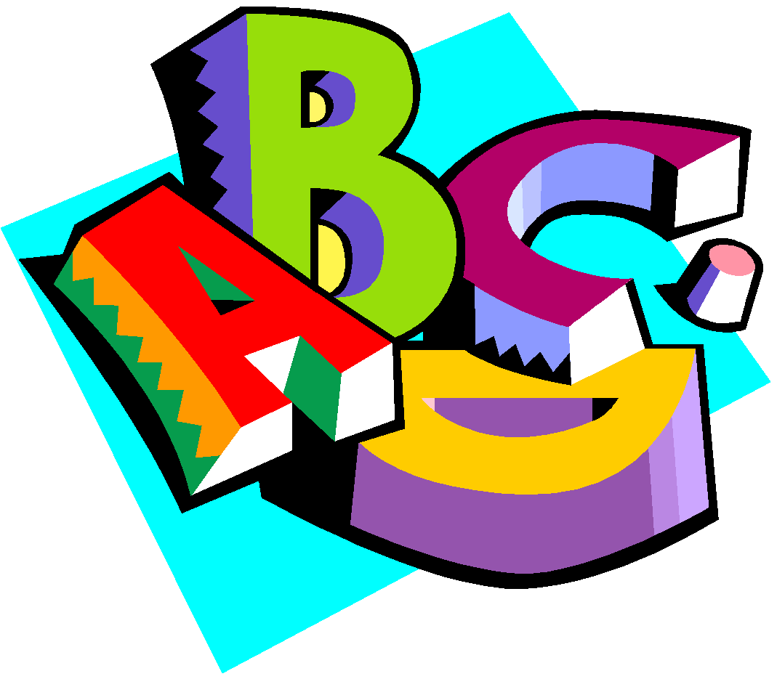
You Can Help ...
- Have attractive colourful books in the home.
- Read your children a variety of stories from time to time. He/she will get to associate these wonderful tales with books and reading.
- You must convey to him/her gradually that books are precious things. They must be minded and handled carefully and put away safely.
- Look at the pictures with him/her and talk to him/her about what they say.
- Read nursery rhymes. Children will learn them off their own bat. Don’t try to push them.
- Above all, don’t push them with early reading. You may turn them against it for evermore.
- Remember that the teacher is the best judge of what rate of progress is best suited to each child.

Understanding Maths
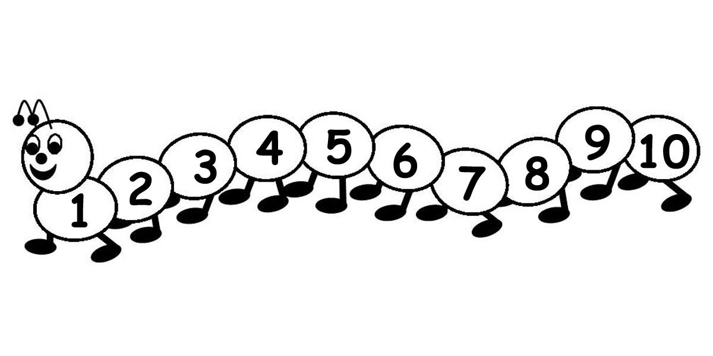

First a Word of Warning
Maths for the small child has nothing to do with “sums” or figures or tables or adding or subtracting. These will all come much later. Maths is really part of the language children use in understanding and talking about certain things in his/her daily experience e.g.

- He/she associates certain numbers with particular things - two hands, four wheels, five fingers etc.
- Counting - one, two, three, four etc.
- Colours - black, white, red, green etc.
- Prepositions (telling position) and their opposites:
over/under, before/after, inside/outside etc.
- Matching/Sorting - objects of the same size/colour/texture/shape etc.
- Odd One Out - difference in size/colour etc
Understanding of these concepts comes very quickly for some children. For others it takes a long time. Be patient. You cannot force Maths understanding on a child.

SOME IMPORTANT AREAS OF EARLY LEARNING

Developing the Command of Spoken Language

It is important that the child’s ability to talk is as advanced as possible. It is through speech that children communicate their thoughts and feelings, their needs and desires, curiosity and wonder. If they cannot express these in words they will tend to remain silent and will often withdraw from the learning activity of the class. This can be the first sign of failure in the school system and must be remedied, if at all possible. This is why a lot of attention is given to language development in the first years of school.
You Can Help ....

- Talk to your child naturally and casually about things of interest that you or he/she may be doing at home, in the shop, in the car etc. Remember that all the time children are absorbing the language they hear about them. It takes them a while to make it their own and to use it for their own needs.
- Try to make time to listen when they want to tell you something that is important to him/her. But don’t always make him/her the centre of attention.
- Answer genuine questions with patience and in an adequate way. Always nurture her/his sense of curiosity and wonder.
- Introduce her/him gently to the ideas of Why? How? When? Where/ If? etc. These demand more advanced language structures.
- He/she will have his/her own particular favourite stories that he/she never tires of hearing. Repeat them over and over again and gradually get him/her to tell them to you.

FIRST STEPS IN READING

Ability to read is the foundation for all future progress in our school system. However, learning to read is a gradual process and a lot of preparatory work must be done before a child is introduced to her/his first reader.

We very deliberately do not rush or push children into reading. We get them ready for it over an extended period. Reading is something to be enjoyed. It should never start as a chore for the small child. Fill your child’s life with a print rich environment.

The Big Day

Coming in...
When you arrive at the classroom, be as casual as you can. He/she will meet the teacher and the other children.

Hopefully, they will be absorbed in the new surroundings. So having given assurance you will be back to collect him/her, wave goodbye and make your getaway without delay. It’s easier on the child in than it is on you to make this break!

Packed Lunches.
Lunch is an important meal for school-going children. It should provide one third of their recommended daily allowance of nutrients without being high in fat, sugar or salt. It should also provide dietary fibre (roughage). The traditional packed lunch of milk and sandwiches is under attack from a range of convenience foods like crisps, sweets, biscuits, chocolate and soft drinks. Parents and teachers are concerned about this trend but some find it difficult to come up with popular healthy alternatives.

We will ask you to encourage a healthy lunch right from the start. Also, please, only give your child something you feel he/she can easily manage to eat. Children are not normally very hungry at school, so a little snack will do. Please look at the various additives in your children’s food.

The following guide is designed to help you provide quick, appetising and nutritious lunches for your children.

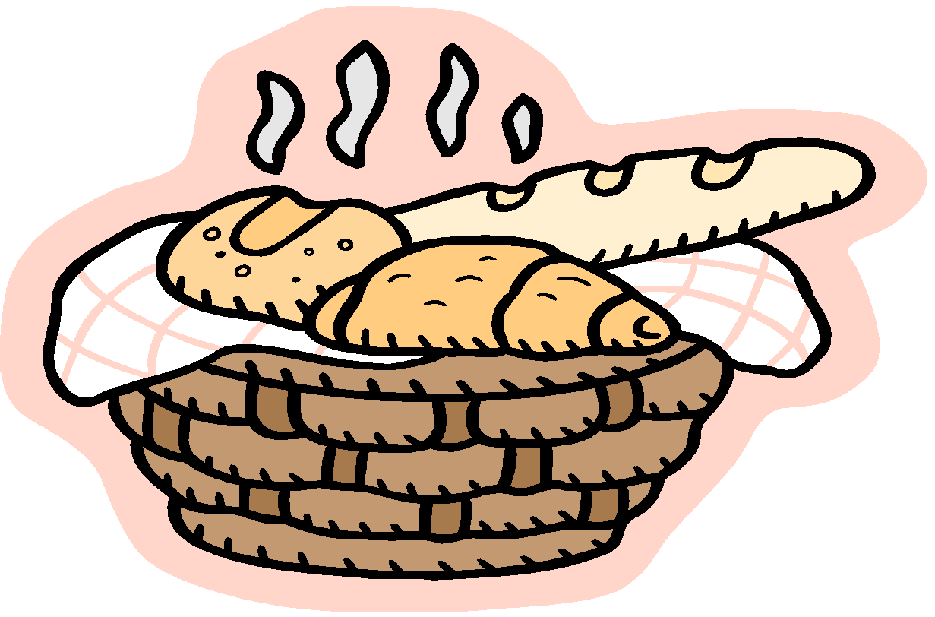

Bread & AlternativesBread or rolls, preferably wholemeal
Rice - wholegrain
Pasta - wholegrain
Potato Salad
Wholemeal Scones

Savouries
Lean Meat
Chicken/Turkey
Tinned Fish e.g. tuna/sardines
Cheese, including Edam, blarney, cottage
Quiche
Pizza.

Fruit & Vegetables
Apples, Banana, Peach, Plum, Pineapple cubes, Mandarins, Orange segments, Grapes, Fruit Salad, Dried fruit, Tomato, Cucumber, Sweetcorn, Coleslaw, Celery.

Drinks
Milk
Fruit juices
High juice squashes, i.e. low sugar content
Homemade soup
Yoghurt.

Start with the Basics
A healthy packed lunch should contain bread or an alternative, a savory filling which provides protein, a suitable drink and some fruit and/or vegetables.

A Word about Milk
Growing children should get approximately one pint of milk a day, or its equivalent as cheese, yoghurt or milk pudding. This ensures that they get enough calcium, which is essential for healthy bones and teeth. If a child does not drink a glass of milk at lunch, encourage him/her to have a carton of yoghurt or a small helping of cheese instead.

As Time Goes On ...

- School begins at 9.20am. To ease the child into the school routine we have a policy where Junior Infants come in for a shorter day than usual for the first few weeks. After that they go home at 2.00 pm. Please make sure that your child is collected at 2.00 pm unless they are availing of the after school service. Get him/her into the habit of being in good time for school from the beginning. Mid-morning break: 11am to 11.10am.(a small snack is sufficient here). Big lunch 12.30– 1 o’clock (lunch required)
- Children need plenty of rest after the effort and excitement of a day at school. You should ensure that they go to bed early and have a good night’s sleep.

- When he/she has settled in and hopefully, looks upon school as a “home from home” do continue to show interest in daily adventures. Give an ear if they want to tell you things - but don’t pester your child with questions.
- Mind that you take some of his/her stories with a pinch of salt.
- If his/her progress is slow do not compare him/her adversely with other children while he/she is listening. Loss of self-esteem can be very damaging to children
- He/she is not going to be a model of perfection all the time - thankfully. You should try to have patience with his/her shortcomings and praise for his/her achievements.
- Children often “forget” or relay messages incorrectly, so please, check your child’s homework journal each night for notes.
- You have received a list outlining the book bill and other bits and pieces your child will need for the year. We would appreciate if the money for Arts and Crafts and the money for photocopying and the School were paid before the end of September if possible. Stage Payments are also an option you may wish to discuss with the Principal or class teacher. As the year goes on, there may be other demands on the purse strings, but they are optional.
These include school photos, tours etc. Further details will be given during the year.

HANDLING THE UPSET CHILD

In spite of the best effort of both teacher and parents a small number of children will still become upset. If your child happens to be one of them don’t panic. Patience and perseverance can work wonders.

A Word of Advice
- Trust the teacher. She is experienced and resourceful and is used to coping with all kinds of starting-off problems.
- Try not to show any outward signs of your own distress. Sometimes the parents are more upset than the child and are the main cause of his/her anxiety.
- When you have reassured him/her, leave as fast as possible. The teachers can distract and humour him/her more easily when you are not around.
- Check back discreetly in a short while. (Feel free to phone the school to check on your child as this will help put your mind at rest.) You will invariably find that calm has been restored.
- You must be firm from the start. Even if a child is upset you must insist that they stay. He/she must never feel that he/she is winning the psychological battle of wills.
- On day one take as many photos and videos as you like. It is a great day for children, parents and school.

School Lunches

School lunches are provided each day for pupils. They include a choice of fruit, a drink and a frube at sos beag ( 11-11:10 am). Children can choose from the following options for their sandwiches at lunch time - ham, cheese, tuna, & plain. Homemade vegetable soup may be provided on request. The school secretary distributes a lunch menu for you to help choose a weekly option with your child. Please inform the class teacher and Lunch Supplier of any dietary restrictions your child has in place.

Treat Day.

Treat Day is on Friday only! We allow the children to bring in a small treat for themselves as a reward for good behaviour during the week. This is totally optional for you as parents .

Going Home
- Be sure to collect your child on time. Children can become very upset if they feel they are forgotten. Infants must be collected at 2pm unless they are availing of our afterschool service. School finishes for all pupils at 3pm. The children must be collected on time due to Board of Management concerns with regards to school insurance.
- Junior Infants can be collected from classroom. We advise parents of Infants to meet their child at the school gate at home time. Unfortunately, our school is located on a very busy and dangerous road and we would feel more secure if the Infants did not leave the school grounds without adult supervision. Moving cars and buses pose a threat to your child’s safety.
If at any time the collecting routine has to be changed ensure you tell the child and the school through a phone call to the secretary, principal or class teacher. Emergencies can also arise so a phone call to the school will ease anxiety and stress levels!

Glencastle N. S. Healthy Eating Policy.

Aims: 1. To improve the nutritional quality of lunches
2. To familiarize children with the food pyramid and with the value of exercise.

- We will do this by educating the children to make healthy food choices. All classes will receive at least two lessons on healthy eating each term. A link may be made with the home when lessons are completed.

- Everyday is a healthy lunch day. A healthy lunchbox includes a piece of food from each of the first four shelves of the Food Pyramid.

- Friday is our treat day. On this day one piece of food from the top shelf of the pyramid may be included.

- Cans and glass bottles are not allowed for safety and litter reasons. Children are asked to use a plastic bottle for their drink. Water, milk, soup and unsweetened juice are healthy choices.

- Foods that have wrappers are to be kept to a minimum to help protect our school environment.

- Healthy eating will be encouraged at all times. Support of parents will be most beneficial and greatly appreciated.

Foods not allowed are: Peanuts, chewing gum and fizzy drinks. Sweets crisps and chocolate bars are limited to Fridays only!

Make the right choice, the healthy choice: join our healthy school team!

After school service

The school is delighted to be in a position to provide an after school service for the pupils in both junior and senior infants. As you are aware, the school day finishes at 2pm for these pupils. Some of these children have siblings in other classes and their parents have to make two school runs in the afternoon. We offer our after school service for a nominal fee to alleviate this inconvenience. Infants travelling on school transport must be collected from school at 2pm unless their parents are availing of our after school service. Children can avail of this service either on a part-time or full-time basis. Parents only pay for the days their child / children have availed of the service. Many parents feel that this service provides social interaction between pupils and encourage their children to attend. Our school secretary supervises the children. Further information is available on request.

