Access to Online School Books for Parents

Folens online registration for parents.

Folens online have given access to all their online digital resources for the next few weeks.

Details on how to register are below.
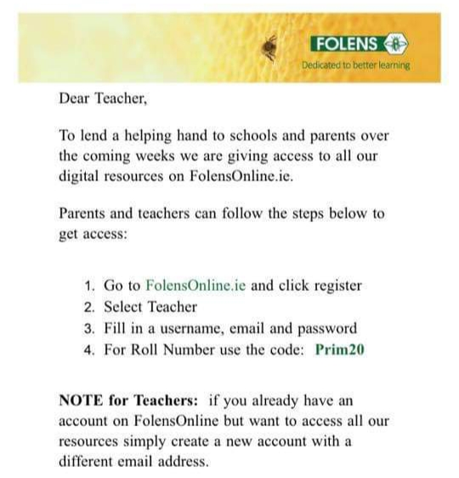

CJ Fallon online registration for parents
​In response to COVID-19, teachers, parents and pupils can access the online versions of all CJ Fallon books for free. Then filter to the title you require, making sure 'Online Book' is selected under ‘Resources'.

https://www.cjfallon.ie/

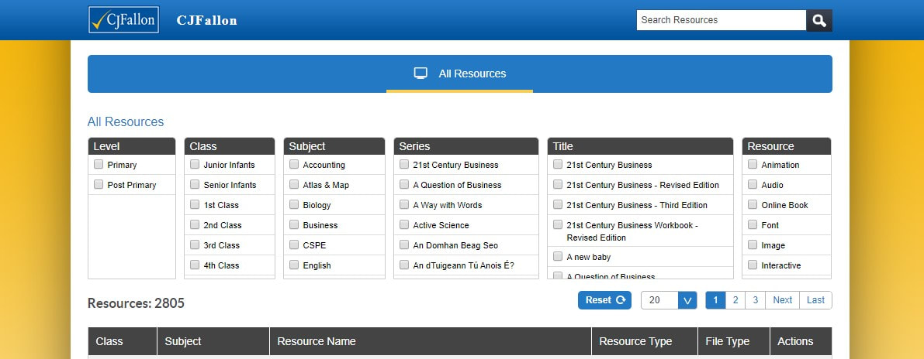

Prim-Ed publishing online registration for parents

Prim-Ed Publishing is offering free parent packs for classes Senior Infants to Sixth class. All you have to do is sign up on their website and fill in a form and you will get the packs sent straight to your email.

https://www.prim-ed.ie/blog/post/parent-information-centre/

