     

Scoil Mhuire Gleann A’Chaisil

Bun na hAbhna, Béal an Átha, Co. Mhaigheo

(097) 82283
www.glencastlens.ie
email:gleannachaisil@gmail.com
Charity Number 20129552

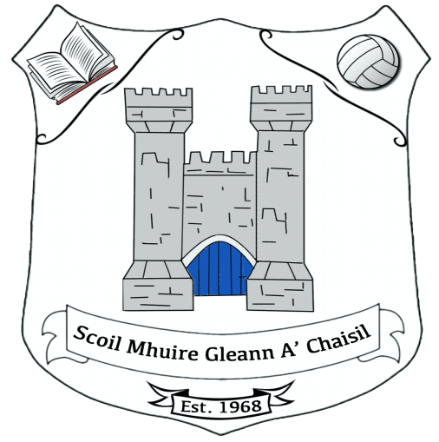

Rolla Number 13222P
Annual Admissions Notice for Glencastle N.S. in respect of admissions to the 2026/2027 school year.

Admission Policy and Application Form:
A copy of the school’s Admission Policy is available as follows:
To download at: www.glencastlens..ie
By phoning: 097 82283
By emailing: gleannachaisil@gmail.com @gmail.com
By writing to: Glencastle N.S., Bunnahowen P.O., Ballina, Co. Mayo. F26 NP79
Application and Decision Dates for admission to Glencastle National School 2026 (Junior Infants)
The following are the dates applicable for admission to Junior Infants
The school will commence accepting applications for admission on: | 7th May 2026
The school shall cease accepting applications for admission on: | 10th May 2024
The date by which applicants will be notified of the decision on their application is | 14th May 2026
The period within which applicants must confirm acceptance of an offer of admission is | 1 month

Application and Decision Dates for admission to Glencastle N.S. Autism Classes.
The following are the dates applicable for admission to the school’s Autism Classes :
The school will commence accepting applications for admission to the Autism class in | 7th May 2026
The school shall cease accepting applications for admission to the Autism class in | 10th May 2026
The date by which applicants will be notified of the decision on their application for admission to the Autism class is | 14th May 2026
The period within which applicants must confirm acceptance of an offer of admission is | 1 month
Note: Failure to accept an offer within the prescribed period above may result in the offer being withdrawn.
The following are the dates applicable for admission to the school’s Multiple Class which caters for children with two or more low incident disabilities
The school will commence accepting applications for admission to the Multiple class in | 7th May 2026
The school shall cease accepting applications for admission to the Multiple class in | 10th May 2026
The date by which applicants will be notified of the decision on their application for admission to the Multiple class is | 14th May 2026
The period within which applicants must confirm acceptance of an offer of admission is | 1 month
Note: Failure to accept an offer within the prescribed period above may result in the offer being withdrawn.
Number of places being made available in September 2026:
The number of places being made available in Junior Infants is | 15
The number of places being made available in our ASD classes is | 7
The number of places being made available in our Multiple Class is: | 0

Glencastle National School will cooperate with the National Council for Special Education in the performance by the Council of its function under the Education for Persons with Special Educational Needs Act 2004 relating to the provision of education to children with special educational needs, including in particular by the provision and operation of a special class or classes when requested to do so by the Council.
Glencastle National School will comply with any direction served on the patron or the board, as the case may be, under Section 37A and any direction served on the board under section 67(4B) of the Education Act.

