Healthy Eating for Wellbeing
Policy
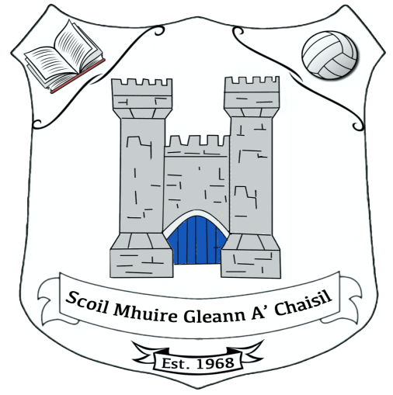

Scoil Mhuire Gleann A’Chaisil
Glencastle National School
2023

Is fearr an tsláinte ná na táinte
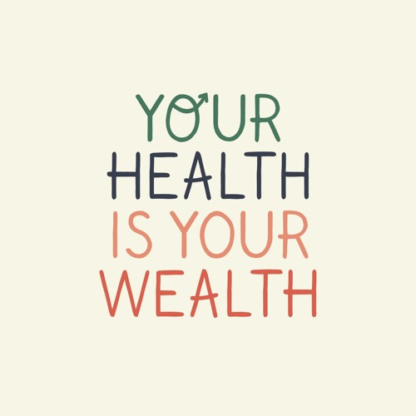
Rationale –
The Social, Personal, Health, and Education (SPHE) Primary School Curriculum Guidelines aim to promote the personal development and wellbeing of the pupil and to provide a foundation for healthy living in all aspects. Glencastle N.S. is committed to facilitating the development of pupils’ skills and attitudes to allow them to make informed decisions about balanced nutrition, food choices and intake and to develop an awareness that good eating habits formed in childhood influence health, happiness and wellbeing throughout our lives.
This Healthy Eating Policy developed in consultation with the whole-school community which includes Teachers, SNAs, pupils and parents as part of the school planning process will help to integrate healthy eating into home and school life.
Recent research has highlighted disturbing trends, including an increase in diabetes and childhood obesity and 1 in 3 are overweight or obese by the age of 11. Therefore, our policy and guidelines review is both timely and critical. Schools are well placed to support pupils to develop an understanding of the nourishment of common and easily accessible food products and facilitate the development of the skills and attitudes to make informed decisions about their food intake. Reference documents include: https://assets.gov.ie/24725/07cc07626f6a426eb6eab4c523fb2ee2.pdf https://www.hse.ie/eng/about/who/healthwellbeing/our-priority-programmes/heal/healthy-eating-guidelines/ https://circulars.gov.ie/pdf/circular/education/2016/13.pdf
From September 2023, The Minister for Social Protection Heather Humphreys has announced the roll-out of the free and compulsory Hot School Meals Programme to every DEIS Primary School in Ireland and this includes Glencastle National School. The nutrition standards for School Meals are being published under the auspices of Healthy Ireland, the national Framework which aims to improve the health and well-being of the population of Ireland. Healthy Ireland takes a ‘whole of Government’ and a ‘whole of society’ approach to addressing the determinants of health, including education, and supporting healthy lifestyles across the life course. One of the four goals of Healthy Ireland is to reduce health inequalities and ‘giving children the best start’ is one of the most important actions for reducing inequalities. https://www.gov.ie/en/publication/484f17-nutrition-standards-for-school-meals/#:~:text=for%20reducing%20inequalities.-,Nutrition%20Standards%20for%20School%20Meals,View,-Part%20of
Based on this announcement, our Healthy Eating Policy was developed. This policy is whole-school and school community-based and was developed in collaboration with teachers, SNAs, pupils and parents through consultation, surveys and feedback.

Findings from the surveys included the following:
- Majority of pupils and school staff are in favour of the Hot Meals Programme
- Pupils are looking forward to tasting and trying new foods
- Pupils need more time to eat
- Pupils want to be healthier and fitter
- Small treats are better than big treats and it’s better to save treats for special occasions or the weekend
- Pupils want to attend school every day and strive to follow and achieve our ‘Every School Day Counts’ campaign.
- At school, pupils are happy to replace Friday Teats to special occasions only
- Pupils are looking forward to replacing Friday Treats with Flexible Time
(Flexible Time is based on non-food treats and encourages fun and the overall healthy wellbeing of your child. Flexible Time may include extra P.E., playtime, Art, Music, Movie Time, games, less/no homework, etc. Alternative activities will be chosen by the class teacher in consultation with the pupils on an ongoing basis).
- Pupils would like to experience and be more involved in growing their own fruit and vegetables
- Pupils would like to experience and be more involved in preparing and cooking their own healthy meals at home
- Pupils are willing to participate in Healthy Eating and wellbeing activities and competitions
- Pupils want to learn and work in a healthier environment
- Staff want to teach and work in a healthier environment
- Pupils enjoy learning about the importance of nutritious foods and their benefits
The benefits of healthy eating include the following:
- It helps a child make the most of their education
- It improves school attendance
- It helps a child to concentrate and learn better at school
- Pupils are benefitting from warm and nutritious food for growth and development
- It improves physical and mental health and wellbeing
- It promotes positive behavioural and emotional wellbeing
- Pupils enjoy social interaction with their peers.
- Pupils are experiencing different tastes and textures of food.
- Providing children with food in school is making a difference to families, both in terms of money saved and for some families, in time saved in food preparation.
- Overall, it gives children the best start and promotes a happier and healthier childhood
The Team
Mary Lavelle -Healthy Eating Policy coordinator
Catherine McIntyre –Principal
Lisa Carolan -Assistant Principal
Consultation Team –A focus group of 6 children to represent each the pupils-(1 from the ASD Unit, 1 from the Junior Room. 2 from the Middle Room and 2 from the Senior Room)

Aims
By having a healthy eating policy, the school hopes to achieve the following:
- To take a whole school approach to healthy eating and nutrition in school, in relation to: the Culture and Environment, Curriculum (Teaching and Learning), Policy and Planning, Relationships and Partnerships.
- To promote healthy eating across school life, and the school community consistent with national healthy eating guidelines and school curriculum
- To ensure that food provision in school reflects the ethical and medical requirements of staff and pupils.
- To understand that a healthy well-balanced diet has many positive benefits and ensures the healthy development of a healthy body, mind and wellbeing of each pupil.
- To develop an awareness that good eating habits formed in early childhood influence health, positive behaviour and well-being throughout our lives
- To inform the adults of the school community about healthy eating in school and remember that they have a responsibility to be good role models for the children.
- For each child to understand that they have a voice and a choice and are also responsible for the food choices they make.
- To explore, taste and enjoy the different types of foods available to us
- To promote the importance of mindful eating and the important role mealtimes play socially
- To Remember to be environmentally friendly when it comes to food packaging, storage and waste
- To make the provision and consumption of food an enjoyable and safe experience.
Objectives
In order to achieve these aims, the school hopes to take the following actions:
There are many opportunities in the primary school curriculum for learning about the importance of food and living healthily
- SPHE Primary School Curriculum Strand Units “Taking Care of my Body / Food and Nutrition “and “Making Choices” The importance of balanced nutrition and healthy food choices is explicitly taught through the SPHE curriculum. We wish to promote ‘the personal development and wellbeing of the child and to provide a foundation for healthy living in all its aspects’. (SPHE Guidelines)
- Science Primary School Curriculum Unit “Living Things / Myself / Human Life Processes”
- P.E. Curriculum and physical activities
- In addition, Healthy Eating will also be taught in other subjects such as Science, Geography, Art, English and Irish.
- A copy of the healthy food pyramid will be displayed in every classroom at different intervals throughout the year.
- School staff will provide supportive attitudes on an ongoing basis to encourage healthy eating. All classes will be discreetly reminded and praised for their efforts in choosing healthy food and drink options eg in class, at assembly time. We will also hold a Healthy Eating Awareness Week annually.
- In keeping with environmentally friendly guidelines, all food and water should be packed in recyclable containers and reusable cutlery will be used. All waste and uneaten food is to be taken home each day.
- Pupils are encouraged to have a role in preparing their own meals at home in order to promote responsibility for their own health and nutrition.
- Where possible, staff will attend professional training and share it with the school community.
- Staff will provide non-food rewards such as Flexible Time during school.
- The school will try to provide measures for any ethical and medical requirements of staff and pupils, e.g. religious, ethnic, vegetarian, medical and allergenic needs.
- Substitute /Visiting Teachers and new staff will be made aware of the contents of this policy. If required, updated information will be made available in the New Pupil’s Enrolment school packs
- External agencies such as HSE, Sports bodies, and nutritionists will be invited to support this policy in line with the guidelines in Department of Education and Skills Circular 0042/2018.
- If not availing of The Hot Meals programme, https://www.glencastlens.ie/policies Any support with up-to-date information on healthy eating habits is available on request.
- A copy of this policy will be made available to all School Staff by email or by hardcopy on request. A hard copy will also be available in the Principal’s and Coordinator’s Policy Folder.
- This policy will be communicated to the whole school community through the school’s website https://www.glencastlens.ie/policies
Roles and Responsibilities
Role of the Parents:
The home plays the primary role in determining healthy eating habits. The school is aware that the primary role model in children’s healthy eating education lies with parents. Glencastle N.S. promotes a positive and supportive relationship with the parents of children at our school through mutual understanding and cooperation.
- Breakfast: A nourishing breakfast is the best start to your child’s day giving him/her the energy needed to concentrate and learn. Research has shown that children benefit both nutritionally and behaviourally by eating breakfast.
https://www.schooldays.ie/articles/Importance-of-breakfast-for-kids-and-teens
https://www.safefood.net/healthy-breakfast
https://www2.hse.ie/living-well/healthy-eating/families/
- As part of environmental awareness, we encourage reusable water bottles, lunch boxes and minimum use of wrapping
- Encourage healthy eating at school and at home
- Inform the school of any child’s special dietary needs
- To provide clean lunchboxes/bags daily
- Be mindful of the Glencastle N.S. Healthy Eating Policy

Role of the Pupils:
- To eat healthy and well-balanced nutritious food at school and at home As part of environmental awareness, we encourage reusable water bottles, lunch boxes and minimum use of wrapping
- To bring home any uneaten lunch
- To remind their parents of the Healthy Eating Policy
- To be cognisant of the Glencastle N.S. Healthy Eating Policy

Role of School Staff:
- To teach and promote healthy food choices and nutritional awareness
- To support and encourage consistent healthy eating habits in pupils
- To provide the whole school community with clear information
- To promote Glencastle N.S. Healthy Eating Policy

A new environment for Healthy Eating for Wellbeing
In conjunction with the Hot Meals Programme, Glencastle N.S. have updated our school’s healthy eating guidelines.
- Small Break: 11-11:10 Water and a piece of fruit will be supplied by the school. Please feel free to send in other fruits and vegetables that your child may enjoy also, and Recreational Time
- Big Break: 12:20-1:00 Water, hot lunch and Recreational Time.
- To promote mindful eating and the social aspect of eating, pupils will have adequate time to sit and eat before going to the yard. Additional eating time may be provided before or after the break when required.
- We request that a set of cutlery (a fork, knife and spoon) be sent in at the beginning of the school year. The cutlery will be washed and cleaned daily and will remain in the classroom. Unfinished food and drinks will be sent home in the pupil’s lunch boxes/bags. To prevent any book spoilage from spillages and leakages, these lunchboxes/bags will be kept separate from their school bags. Please provide a clean lunchbox/bag daily.
- Drinks: Water only. Please send in a suitable container of water with your child each day. To avoid spillage, please check that the container is sealed properly. Additional water is available in the school if required.
- Due to high sugar content, tooth decay, allergies and your child’s general health, chocolate spreads like Nutella, Frubes, Petits Filous and Miwadi are no longer available or encouraged.
- Treat Friday at school is being replaced with Flexible Time. Food Treats in school will be kept for special occasions and celebrations only such as holiday time, Communion and Confirmation. etc
- Pupils and parents are requested not to send in the following unhealthy food treats with their child’s lunch; chocolate spreads, sugary yoghurts, chocolate, crisps, sweets, biscuits, chocolate/yoghurt-covered rice cakes, cereal bars, concentrated drinks like Miwadi, fizzy drinks, sports drinks, sugary drinks, smoothies etc
Implementation
Both the Wellbeing Policy Statement and Framework for Practice and the Healthy Lifestyle Circular 13/2016 support the school’s work in this area.
Parents’ support and encouragement of consistent healthy eating habits is essential, and if unhealthy food or drink continues to be brought to school, the school will communicate with parents to remind them of the importance of supporting the Healthy Eating Policy.
The Healthy Eating Policy Team will finalise this policy which will be subsequently ratified by the Board of Management in June 2023.
Glencastle N.S. Healthy Eating Policy for Wellbing will be shared by email with school staff and will be available for parents and the whole school community on the school’s website. https://www.glencastlens.ie/policies
A review of our Healthy Eating Policy will be every two years or earlier if required.
Signed:
Tom McAndrew (Chairperson) ________________________________________
Catherine McIntyre (Principal) _______________________________________________
Date: __________________________________

